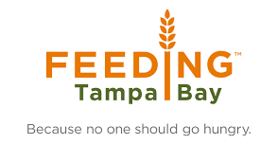

DHMS and Feeding Tampa Bay

are working together to feed Dunedin Families!

**ALL are welcome to sign up and receive a FREE food box at the school from 2:30 to 4:00 p.m. on Thursdays.**

Prepared boxes will be ready for pickup in the front office.

Please email Ms. Schardt at [Schardtl@pcsb.org](mailto:Schardtl@pcsb.org) or call 727-469-4112 ext. 2071 to get signed up.

In your email, please include your name, phone number,

# of children, and # of adults in your family

\***Please list any food allergies**

Dunedin Highland Middle School: 70 Patricia Ave. Dunedin FL 34698 P: 727-469-4112